Tab 1

### Contract Processing Steps *(Implementation/Success to fill)*

Contract may include the following:

* Setup Fee
* Initial fee credited against the first month
* Remaining license fees

1. Steps to process

**SETUP FEE**

***If there is a setup fee listed****, like the screenshot below, follow the steps to process:  
  
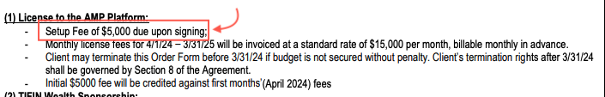*  
  
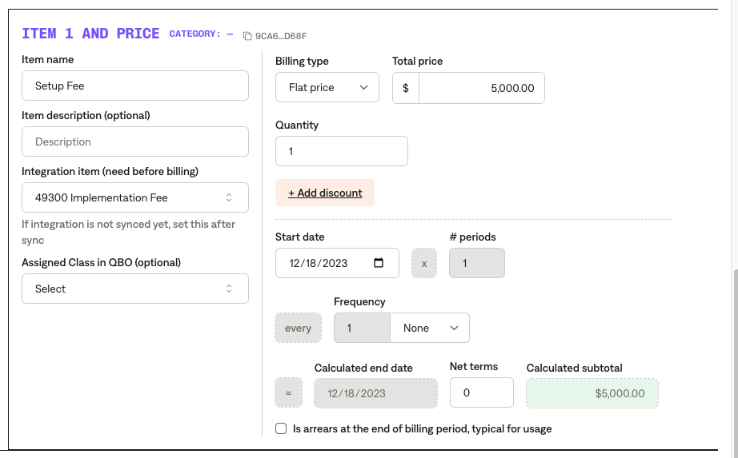  
**Service Start Date:** Search for “effective date”  **Months of Service:** Will be listed in term **Item Name:** Setup Fee **Item Description:** none **Integration Item:** [TIFIN Netsuite Integration Items](https://docs.google.com/spreadsheets/d/1fAQ1rHf_buFcowql7ONgAj6gY01wd3u6nwM4ZAUxqhY/edit?gid=515133391#gid=515133391) find here  **Billing type:** Flat **Total Price:** Found in contract **Quantity:** 1 **Start Date:** Same as service start date **Periods: null  
Frequency:** NONE **Net Terms:** 0

# **Initial fee credited against the first month**

*If there is a bullet that mentions the initial fee credited against first months fees, process like the following:*

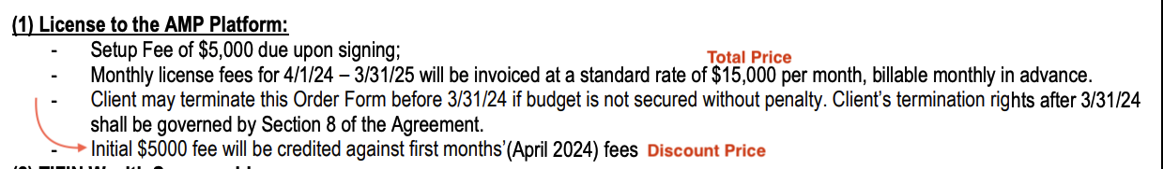

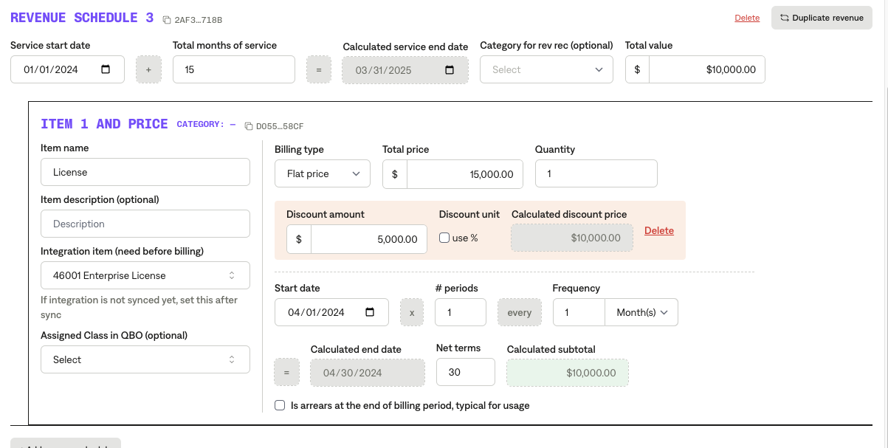

**Service Start Date:** Mentioned in contract section  **Months of Service:** Mentioned in contract  **Item Name:** License  **Item Description  
Integration Item:**[**TIFIN Netsuite Integration Items**](https://docs.google.com/spreadsheets/d/1fAQ1rHf_buFcowql7ONgAj6gY01wd3u6nwM4ZAUxqhY/edit?gid=515133391#gid=515133391) **find here   
Billing type:** Flat **Total Price:** Refer to contract, see screenshot above

**Discount:** Refer to contract discount above in screenshot, this will typically be the price of the initial fee  **Quantity: 1  
Start Date:** Refer to contract start date  **Periods:** 1  **Frequency:** 1 month  **Net Terms:** 30

# **Remaining License Fees**

*Process monthly licenses like this:*

**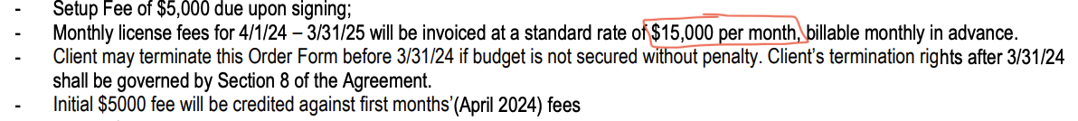  
Service Start Date:** Mentioned in contract **Months of Service:** Mentioned in contract **Item Name:** Licenses **Item Description  
Integration Item:** [TIFIN Netsuite Integration Items](https://docs.google.com/spreadsheets/d/1fAQ1rHf_buFcowql7ONgAj6gY01wd3u6nwM4ZAUxqhY/edit?gid=515133391#gid=515133391) find here  **Billing type:** Flat **Total Price:** Mentioned in contract,  **Quantity:** One **Start Date:** ONE MONTH AFTER DATE MENTIONED, Example: 5/1/24 for this one since the first month already got charged  **Periods:** 11 if it is a one year contract, it will be the length of the contract minus one month  **Frequency:** monthly  **Net Terms:** 30

1. Anything to ignore in contracts?
2. Specifics processing things the merchant has requested that may differ by contract (e.g. always back-date invoice date to final day of the month)
3. Default Service Term
   1. If None Listed, Ops Default is 1 Year
4. Default Net Payment Terms
   1. If None, Ops Default is 0
5. Default Billing Frequency
   1. If None Listed, Ops Default is Monthly
6. How do we handle taxes as a line item?
   1. If None Listed, Ops Default is every tax line item becomes a BT

### Events Processing (if necessary) *(Implementation/Success to fill)*

* Any important information on events billing

Integration Items Processing (if necessary)  
*(Implementation/Success to fill)*

* What are the instructions for assigning integration items? [TIFIN Netsuite Integration Items](https://docs.google.com/spreadsheets/d/1fAQ1rHf_buFcowql7ONgAj6gY01wd3u6nwM4ZAUxqhY/edit?gid=515133391#gid=515133391)
* Example: All Statsig integrations items should be labeled as “Sales”
* Example: All “Pinata” integration items should be labeled as “Software Subscription Bundle” unless otherwise noted by Merchant